Teacher Name: Mr. Chakraverty

Name of Class: U.S. History

Period #:            All

Assignments:      Week5:

* + - Weekly News Updates (complete summary)
* DBQ Q&A
* Vocabulary unscramble and crossword

Student Name: _________________________________

Teacher Name: _________________________________

Name of class:  ______U.S. History________________

Period #:            _________________________________

Assignment #:   ______5_________________________

Attached:

News Summary

Document Based Question and Answer

Context Vocabulary unscramble

Context Vocabulary Crossword

**WEEKLY NEWS UPDATES:**

Students watch a news program or read a news article and write the following information:

* Date of story/publication
* Source (CNN, BBC, ABC, Fox, Reuters, AP etc)
* 1x “I noticed ______________________________________________________.”
* 1x “I wonder _______________________________________________________.”
* You can either watch the news on television, an on line resource like CNN10, a newspaper or an on-line news agency.

**Example:**

**Date: April 2, 2020**

**Source: CNN10**

**I noticed that there are over 329 million people in the United States and over 80% of them have been told to stay at home.**

**I wonder what will happen to people that do not follow the stay at home orders.**

**Your Summary:** (5 Points)

**Date:**

**Source:**

**I noticed:**

**I wonder:**

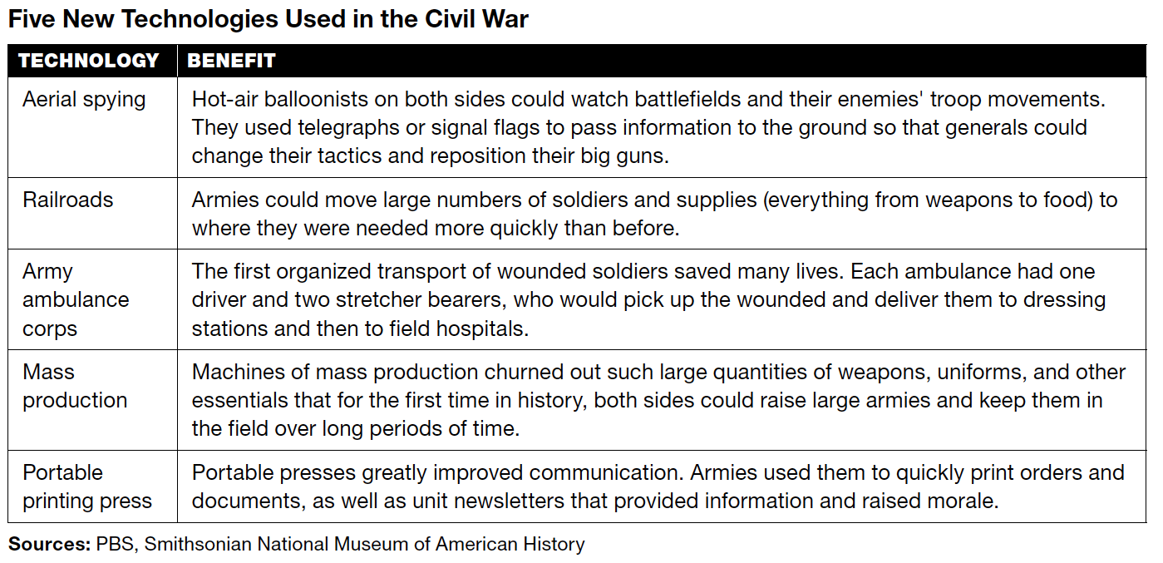

1. Which technology was useful in gathering information?

|  |  |
| --- | --- |
| a. | railroads |
| b. | aerial spying |
| c. | portable printing press |
| d. | mass production |

2. Which technology helped provide soldiers with supplies?

|  |  |
| --- | --- |
| a. | mass production |
| b. | portable printing press |
| c. | ambulance corps |
| d. | aerial spying |

3. How did balloonists get their information to commanders?

|  |  |
| --- | --- |
| a. | They dropped notes to the ground. |
| b. | They used portable printing presses. |
| c. | They used telegraphs or signal flags. |
| d. | They landed and hand-delivered notes. |

4. Based on the chart, what generalization can you make about how new technologies affected the

Civil War? (Use 2 or more complete sentences to answer this question)

ANS:





5. What is the soldier’s condition when he meets Ropes?

ANS:

6. How does Ropes help the soldier?

ANS:

Unscramble the letters to make the correct word that matches the definition BELOW

**3. FDATR 10. BTTTSUIESU 1. RAAE 9. LREBE 8. RPPSCOET 7. SEENVIOFF 6. OSOVUBI 2. BUTYON 4. CIAAEEMTNP 5. NTIAILOFN**

1. Part of a country ___ ___ ___ ___

2. Money given as a reward such as to encourage enlistment in the army ___ ___ ___ __ __ __

3. the selection of persons in the military service ___ ___ ___ ___ ___

4. to free from slavery ___ ___ ___ ___ ___ ___ ___ ___ ___ ___

5. a continuous rise in price of goods and services ___ ___ ___ ___ ___ ___ ___ ___ ___

6. easily found, seen, or understood ___ ___ ___ ___ ___ ___ ___

7. position of attack or the attack itself ___ ___ ___ ___ ___ ___ ___ ___ ___

8. the idea of something that will or might happen in the future __ __ __ __ __ __ __ __

9. Confederate soldier, so called because of opposition to the government __ __ __ __ __

10. a person or thing that takes the place of another __ __ __ __ __ __ __ __ __ __

|  |  |  |  |  |  |  |  |  |  |  |  |
| --- | --- | --- | --- | --- | --- | --- | --- | --- | --- | --- | --- |
|  | 1 | 2 |  |  |  |  |  |  |  |  |  |
|  |  |  |  |  |  |  |  |  |  |  |  |
|  |  |  |  |  |  |  |  |  |  |  |  |
|  |  |  |  | 3 | 4 |  |  |  |  |  |  |
|  |  |  |  |  |  |  |  |  |  |  |  |
| 5 |  | 6 |  |  |  |  |  |  |  |  |  |
|  |  |  |  |  |  |  |  |  |  |  |  |
|  |  |  |  | 7 |  |  |  | 8 |  |  |  |
|  |  |  |  |  |  |  |  |  |  |  |  |
|  |  |  |  |  |  |  |  |  |  |  |  |
| 9 |  |  |  |  |  |  |  |  |  |  |  |
|  |  |  |  |  |  |  | 10 |  |  |  |  |

Use these words to answer the clues and complete the puzzle. Write the word next to the clues and in the shaded boxes above.

DISTRIBUTE, REBEL, OCCUR, EVALUATE, TOTALWAR, DRAFT, INFLATION, YANKEE, OUTCOME, RATIFY,

ACROSS CLUES:

1. To divide among several or many _________________________

3. Confederate soldier, so called because of opposition to the government ______________

6. war on all aspects of the enemy’s life ____________________

7. result ____________________

9. Union soldier _____________________

10. the selection of persons for military service ______________________

DOWN CLUES:

2. A continuous rise in the price of goods and services ________________

4. judge the quality or amount ______________________

5. to give official approval to ___________________

8. to happen ______________________