Teacher Name: Mr. Egenberger
Name of Class: Social Studies
Period #: All
Assignments: Week 1:
- Key Terms and Primary Source Document with related questions.
- Weekly news summary assignment
Assignment Due: Friday April 24 via email to: regenberger@tusd.net, or “paper only” students turn in at school. Even if you are a student who got a paper copy, you can turn in on-line by taking pictures of your answer pages and emailing them to regenberger@tusd.net. For health and safety reasons, the more we can do on-line, the better.

Student Name: _________________________________
Teacher Name: _________________________________
Name of class: ______U. S. History________________
Period #: _________________________________
Assignment #: ______#1_________________________

Key Terms
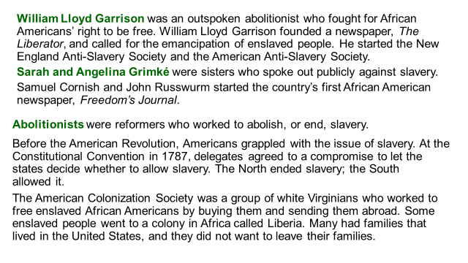
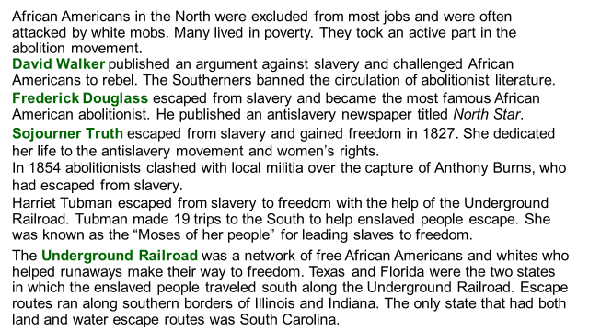

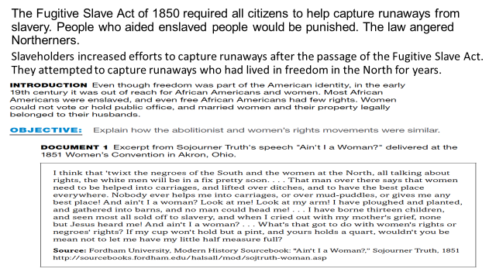

Use the document and information above, as well as any knowledge you have of the abolitionist and women’s rights movements to answer the following questions. Please answer with complete sentences.
- Why does Truth predict “the white men will be in a fix pretty soon”?

- How was Truth different from the women described by a previous speaker?

- How did southerners respond to David Walker’s An Appeal to the Coloured Citizens of the World?
  - Violence against African Americans increased
  - They banned the circulation of abolitionist literature
  - They increased restrictions on free African Americans
  - They increased restrictions

Answer and 2 of 5 the questions below

- Why did people freed from slavery want to stay in the United States?

- What was life like for free African Americans in the North?

- How did slaveholders react to the passage of the Fugitive Slave Act?

- How did William Lloyd Garrison help the abolitionist movement?

- What role did Harriet Tubman play in the antislavery movement?

WEEKLY NEWS UPDATES:
Students watch a news program or read a news article and write the following information:
- Date of story/publication
- Source (CNN, BBC, ABC, Fox, Reuters, AP etc)
- 1x “I noticed ______________________________________________________.”
- 1x “I wonder _______________________________________________________.”
- You can either watch the news on television, an on line resource like CNN10, a newspaper or an on-line news agency.

Example:
Date: April 2, 2020
Source: CNN10
I noticed that there over 329 million people in the United states and over 80% of them have been told to stay at home.
I wonder what will happen to people that do not follow the stay at home orders?

Your Summary:
Date:
Source:
I noticed:

I wonder:

