Tracy Unified School District  gIFTED AND TALENTED EDUCATION (gate)  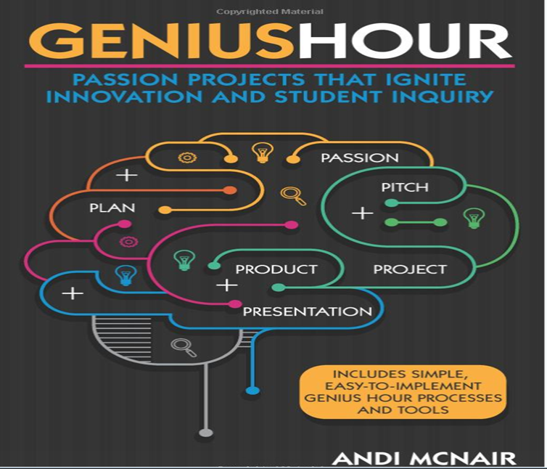  GATE PARENT INFORMATION MEETING  NOVEMBER 4, 2021  Time: 6:00pm  Location: Williams Middle School  1600 Tennis Lane  Multipurpose Room & Library  Come join us to learn what our Tracy Unified School District Gifted and Talented Education (GATE) Program has to offer. Information on the application process, program criteria, program overview and student Genius Hour Passion Projects will be provided.  PDF APPLICATIONS AVAILABLE ONLINE  NOV 5 – DEC 3  https://www.tracy.k12.ca.us/programs/gate  APPLICATIONS DUE DECEMBER 3, 2021 | Is your child curious and a problem solver?  ────────  Does your child seek academic challenges?  ────  GATE Program is modeled after Genius Hour Passion Projects  ────  Student-Centered Learning Environments designed to promote Rigor, Relevance, and  Relationships  Department of Continuous Improvement,  State and Federal Programs  Tania Salinas, Director  (209) 830-3200 ext. 1053  https://www.tracy.k12.ca.us/programs/gate  Web Address

