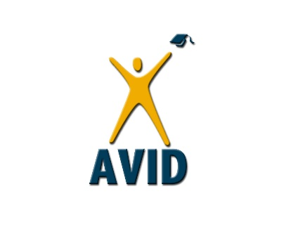
AVID 6th grade-Digital
Week #3: May 4th-May 8th, 2020
Due: Tuesday, May 12, 2020
Teacher: Gonzales (mgonzales@tusd.net)
Objectives:
- To continue with our organization of class assignments.
- To work on our quick writing skills
- To use Cornell Notes to support our learning
- To explore university campuses.
Directions: Write your first and last name on each paper. Complete the following assignments with superior effort. Please go to: http://mvmsgrade6.weebly.com/ under the AVID tab for each assignment below and worksheets to go with them.
Assignments:
- Fill in your agenda with your weekly assignments as you receive work every week. Decide what your will be working on each day and plug it into your agenda. Have your parent sign your agenda for approval. This quarter, you will have to fill in all 5 weekdays and get a parent signature for each of the days. (20 pts) Note: All 5 weeks worth of pages will be turned in for grading at one time on the last turn in day of the quarter.
If you left your agenda at school, make a new calendar with subjects for each week the same as the agenda. No excuses.
- Cornell Notes Assignment for Social Studies
- Comparing Universities Chart and Reflection Questions
How to submit (turn in):

- *Option 1: Take a picture of work or scan into an attachment and send to your teacher on email or send on Office 365. You can find your teacher’s email on the MVMS website or on our 6th grade website.
- *Option 2: Set up a Zoom appointment or other online method to submit work. You will need to communicate with your teacher to arrange this option.

